
Year 10 – Term 2 – Civics and Citizenship (HASS) 2023
NAME: __________________________ Target: _____ / 37
Task 2: High Court, international agreements, government policy and laws – Case Study
Assessment 2: Assessment 2: Case Study - Students research and compile relevant information (case study template) about an international agreement Australia has ratified and examples of how it shapes government policies and laws. (e.g. the protection of World Heritage areas, The Declaration on the Rights of Indigenous Peoples, the Convention on the Rights of the Child or the International Convention on the Elimination of All Forms of Racial Discrimination).
PART 2A: Template (5%)
PART 2B: Validation (In-class) (5%)
PART 2A: Template (5%) Total = 27 marks
You must complete all sections of the A3 template, using depth and detail. You will not be allowed to use the template during the in-class validation.
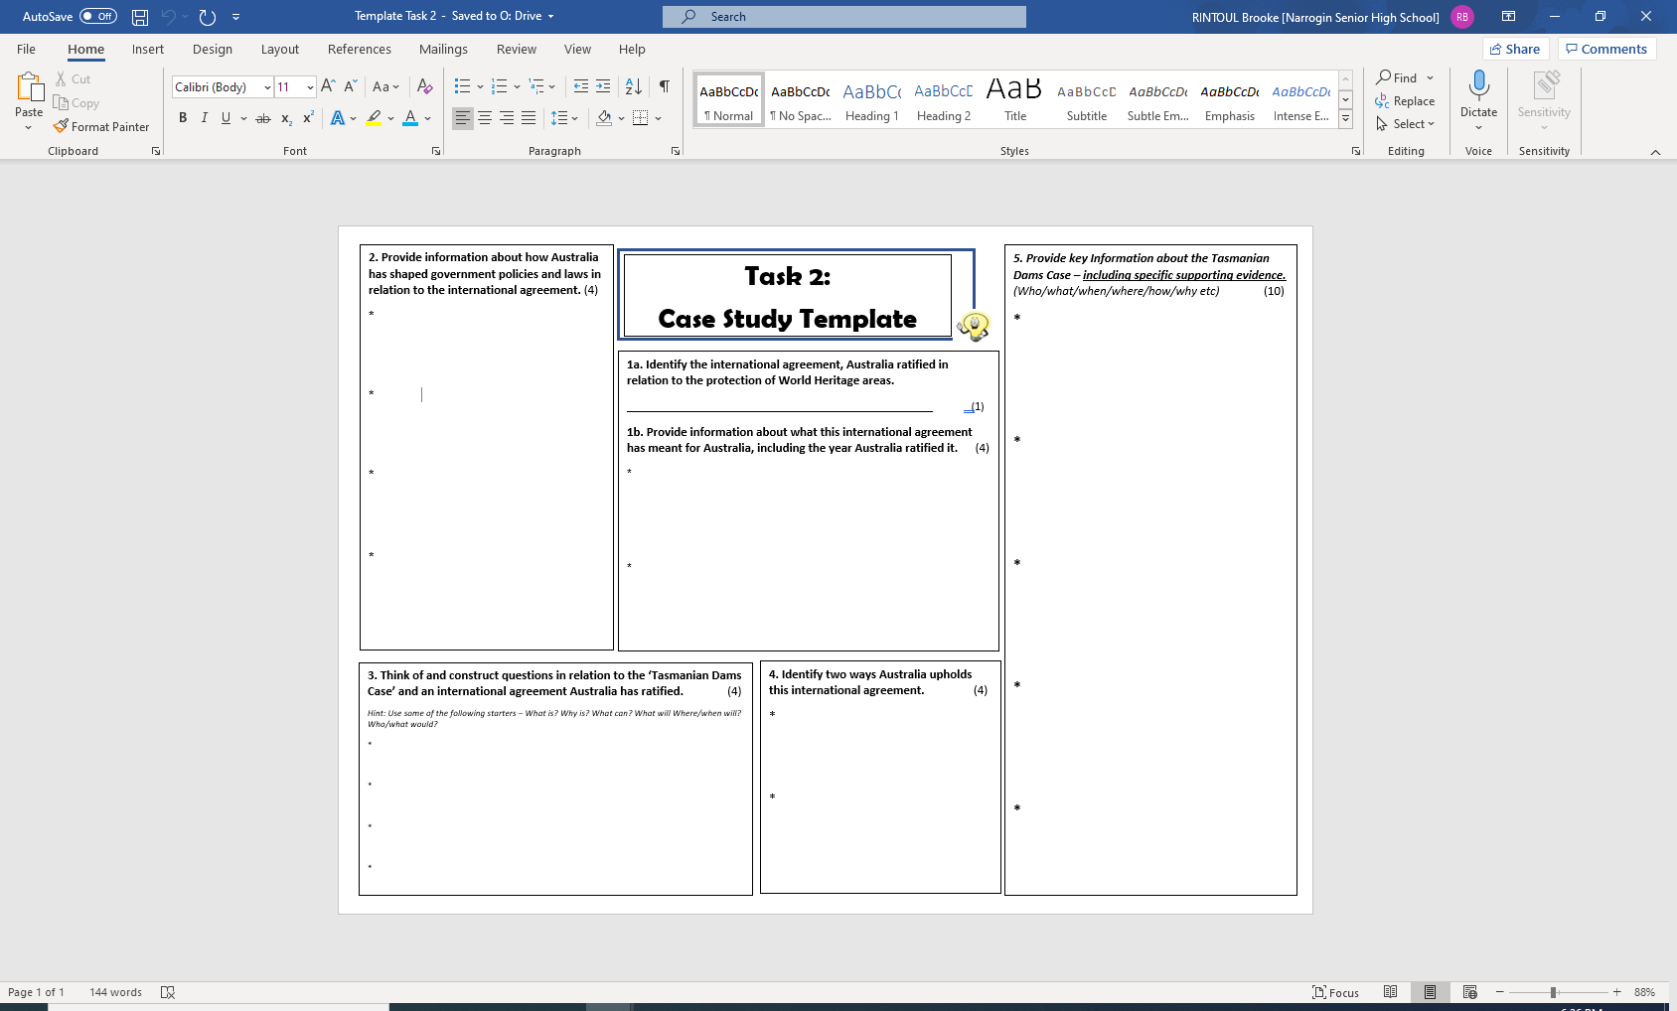
Conditions: 2 lessons in class (1 lesson on computers and 1 lesson in class using books and resources). You can work on this at home also.
PART 2B: Validation (In-class) (5%) (NO notes allowed)
Date: In-class (Week 7, Wednesday 7 June 2023)
Conditions: Test Conditions - 5 minutes planning & 45 minutes working time
Write a response a minimum 400-word response to the following…
Total = 10 marks
Question:
To what extent does Australia uphold ‘the World Heritage Convention’.

Hint: Extent - the particular degree to which something is or is believed to be the case.

Particular points to include and address:
- Background information about the World Heritage Convention, including Australia’s involvement (include supporting evidence, such as examples)
- Supporting evidence – Examples of acts of Parliament (previous and current) Australia has in relation to the World Heritage Convention.
- Supporting evidence – an example of a particular case which has taken place in Australia in relation to the topic. Clearly identifies a case.

Note: You are encouraged to plan your response before writing your response.
PLANNING PAGE: This will not be assessed. You will be given this sheet again in class during the validation. Jot down the key points
Paragraph 1: INTRODUCTION

Paragraph 2:

Paragraph 3:

Paragraph 4: CONCLUSION

